Chad Qian

**Digital Jobs Report**

**Executive Summary**

Digital jobs are an exciting, relatively new part of the economy. They have the potential to lift thousands of people out of poverty, while also helping the World Bank streamline certain routine tasks. At the same time, issues exist with both digital crowdsourcing platforms, from wage issues to power inequities, and with Internet capabilities in emerging economies, from lack of Internet infrastructure to low digital literacy. These challenges, while difficult, are likely not impossible to overcome. In addition, platforms like Amazon Mechanical Turk (MTurk) will likely be useful for future World Bank work, regarding activities like image tagging. Digital jobs, and the role they can play in emerging economies, definitely merit further attention from the World Bank.

**Background on Digital Jobs**

Typically, the common conception of “work” in developed economies is a formal one: The worker is an employee in a firm, and negotiates a contract with his/her employer. This contract stipulates the rules of the worker’s employment, including work hours and work benefits, like healthcare and a pension.

The rise of the Internet, however, has created a new informal sector of the economy, lacking both the structure and the protections of more formal work. This includes on-demand labor; unlike typical formal work, this labor has no fixed schedule, as the name suggests. Notable examples include Uber and other ride-sharing platforms; Uber drivers work according to the demands of Uber riders, rather than according to some contract with fixed hours. A subcategory of on-demand labor is on-demand crowdsourced labor; instead of having one person work on one complex task, this task is split up into much smaller tasks for many more people to work on remotely.

In recent years, these informal sectors of the economy have grown in size tremendously, with Katz and Krueger showing that the percentage of workers engaged in such “alternative work arrangements” in the United States increased from 10.7% in 2005 to 15.8% in 2015.[1] Meanwhile, a study by FEPS showed that 11% of UK adults had successfully done “crowd work” (another term for on-demand crowdsourced labor), with 3% doing it weekly.[2]

Unlike more formal employment, on-demand and crowd-sourced labor is typically less structured and regulated. For workers, this means more flexible employment, along with lower barriers to entry; for instance, people with disabilities, or with busy family schedules, are able to work from home, while the usual anonymity on on-demand digital platforms helps protect against discrimination. On the other hand, workers lack the job security and benefits that more formal employment offers, and typically face lower overall wages too. For employers, this means more flexible hiring, lower costs, and more efficient workflows; on the other hand, they face quality control issues.

There are a variety of on-demand labor platforms, with many distinguishing characteristics. Broadly speaking, however, such platforms can be divided along two axes. The first axis pertains to the amount of skill/knowledge needed to perform tasks on the platform. The second axis pertains to the amount to which the platform company directly interacts with workers. This is illustrated in Table 1, below. For more details on the differences between the different types of platforms, please refer to Annex 1.

|  |  |  |
| --- | --- | --- |
|  | **Low-interaction** | **High-interaction** |
| **Low-skill** | MTurk, Crowdflower  (“Crowd work”) | SamaSource  (Development “crowd work”) |
| **Medium-skill** | TaskRabbit, Fiverr, Upwork  (Freelancing) | No major platforms  (A typical formal job) |
| **High-skill** | InnoCentive  (Outsourced R&D) | No major platforms  (A typical formal job) |
|  | *Table 1* |  |

For emerging economies, the “low-skill, low-interaction” platform is the most relevant one, as barriers to entry are lowest for this type. Unfortunately, this type of platform also has a range of problems, most of which have not been addressed by the platform themselves. These problems include, most prominently, issues of fair payment. As stated above, pay on MTurk and similar platforms is usually abysmal. In addition, the lack of job security and other protections can, in the words of some critics, turn these platforms into “wage slavery.” Moreover, in these platforms, the employer typically has a disproportionate amount of power. For example, with MTurk, an employer could release a survey, collect 100 responses, and then choose not to pay any of the respondents. In that case, the employer still retains the responses, while the respondents have no legitimate way to fight back, aside from the third party browser plugins, like turkopticon, or worker forums, like Turker Nation, that have sprung up. There are other moral issues; for instance, workers who are asked to moderate social media sites on-demand often see horrific images.[3] Worse, some workers might, hypothetically, be unknowingly working for a completely immoral project, such as tagging images of dissidents in China.

On the employer side, there are also issues. A major one is quality control; since the workers are anonymous, trolls who abuse the platform for money can become quite frequently. Another concern is data privacy, as workers could potentially copy data that they see on these platforms. More disturbingly, a malicious actor could hypothetically could go onto the platform, and ask workers to steal data from another employer on the platform.

Again, most “low-skill, low-interaction” platforms have not really addressed these issues. For future World Bank work, we highly suggest that World Bank employees keep these issues in mind.

**Digital Jobs in Emerging Economies**

As discussed above, the digital economy is already having an impact on developed countries. However, a deeper analysis is required to examine the potential impact that the digital economy will have on the developing world.

Before our analysis, we define the terms that we will be using.[4] [5]

* Fragile and conflict affected situations: “Countries with fragile situations are primarily International Development Association-eligible countries and nonmember or inactive countries and territories with a 3.2 or lower harmonized average of the World Bank's Country Policy and Institutional Assessment rating and the corresponding rating by a regional development bank, or that have had a UN or regional peacebuilding and political mission or peacekeeping mission during the last three years. The group excludes IBRD countries, unless there is the presence of a peace-keeping or political/peacebuilding mission.”
* Low income states: A state with a GNI per capita of $995 or less.
* Lower-middle income states: A state with a GNI per capita between $996 and $3,895.
* Upper-middle income states: A state with a GNI per capita between $3,896 and $12,055.
* High income states: A state with a GNI per capita of $12,056 or more.

Now, firstly, we can look at Internet usage rates for these different kinds of countries.[6] We can see in Figure 1 that the richer countries have much higher rates of Internet usage, with high income countries having rates above 80%, as expected. In contrast, both low income and fragile states have rates below 20%. However, these poorer states have also seen great advances in Internet usages, as seen in Figure 2. In fact, from 2006 to 2016, Internet usage rates in both low income and fragile states went up by a factor of 8.

Looking at the number of fixed broadband subscriptions (per 100 people), in Figures 3 and 4, tells a similar story. [7]

Next, we can turn to the number of secure Internet servers (per 1 million people), and use this as a metric for the amount of “Internet infrastructure” in a country.[8] Again, we can see in Figure 5 that high income countries have many more secure Internet servers. However, if we look at Figure 6, we see that the increase in the number of these servers in high income countries is actually quite high too. In fact, from 2010 to 2017, it appears that the number of such servers rose by over a factor of 10 in high income countries. In comparison, the number of these serves rose by only a factor of 30 in low income and fragile countries. This potentially suggests that there should also be a focus on helping maintain and develop current Internet infrastructure in emerging economies, rather than just focusing on expanding it to more people.

As of 2018, there are no suitable measures of digital literacy available for all countries, although the UNESCO Institute of Statistics recently announced a new global framework aimed at measuring it.[9] Despite the lack of such a measure, we can use the metric of social media penetration, as a percentage of total population, as a proxy to get a grasp of the situation.[10] This is provided in Table 2.

|  |  |
| --- | --- |
| Country Grouping | Social Media Penetration (Jan 2017) |
| Low income | 7.0% |
| Fragile states | 13.0% |
| Low-middle income | 22.5% |
| World | 38.5% |
| Upper-middle income | 53.2% |
| High income | 60.0% |
| *Table 2* |  |

We can see that both upper-middle income and high income countries have high rates of social media penetration, while the remaining country groupings have much lower rates. As such, in addition to helping improve Internet infrastructure, digital literacy likely also needs to be greatly improved in these emerging economies.

This contrast, between rapidly increasing Internet penetration and still-low levels of digital literacy, can also be seen anecdotally. For instance, rapid Internet infrastructure growth in Nigeria is killing the once vibrant Internet café industry, as more people gain personal access to the internet, with there being “83 million active phone lines with access to mobile internet” in February 2015.[11] At the same time, a research project by Microsoft team found that low-income workers in India, with 10 to 12 years of schooling, had significant trouble in performing basic tasks on Amazon Mechanical Turk.[12] This was likely due to a combination of low digital literacy on the part of the workers, along with a poor user interface and a cultural disconnect on the part of Mechanical Turk. All of these factors should be kept in mind, when considering the future impact of the digital economy on emerging economies.

More importantly, there is also the question of whether digital jobs will even play a major role in the development in emerging economies. After all, in traditional economic philosophy, manufacturing is key to development. More specifically, the argument goes that, if an agrarian economy wants to develop, it should turn to manufacturing. As a result of worker specialization and economies of scale, this industrialization will drive up productivity growth, urbanization, and exports. After a country has grown rich from industrialization, it will turn to a services-based economy, as its citizens become more interested in buying services with their newfound wealth. Indeed, this has been the economic story for essentially every developed country. And in recent history, this is perhaps best illustrated by countries in East Asia, from the historic success of the four Asian tigers of Taiwan, South Korea, Singapore, and Hong Kong, to the modern success of China.

However, recent history suggests that this “traditional” pathway for economic development might not hold true for some developing countries. India is perhaps the best example of a country that has leapfrogged directly from an agrarian economy to a services-based one.[13] Whether other countries can imitate this “Indian miracle” is debatable; Ghani, et. al, argue that this model is indeed possible.[14] More specifically, they argue that productivity growth for services in emerging economies is increasing; this, in turn, makes services a more attractive vehicle for economic development. Moreover, Ghani, et. al, argue that this increase in productivity growth is being driven primarily by the rapid development of “information communication technology intensive” modern services.

If it is indeed true that developing countries are now able to jump directly from an agrarian, undeveloped economy, to a modern, services-based economy, then digital jobs will likely play a major role in that jump. In fact, this is already occurring, with both private companies, like Samasource in Kenya, and public organizations, like eRezeki in Malaysia, providing these jobs to low income individuals (for further analysis, refer to Annex 2). More specifically, both Samasource and eRezeki are “low-skill, high-interaction” platforms, with Samasource having provided over 10,000 individuals with jobs since it was founded in 2008, and more than 150,000 individuals having participated in eRezeki since it was founded in 2015. In particular, both Samasource and eRezeki provide training to their workers, which helps them attain higher earnings after leaving the program. If this combination of digital jobs and training is scalable, then similar private firms and public organizations could ultimately help many low-income individuals in emerging economies break free from entrenched poverty.

**Experimental MTurk Tasks**

1. Background

Amazon Mechanical Turk was launched publically in 2005; before then, Amazon had used it internally to delete duplicate pages. Amazon Mechanical Turk, as described above, is a “low-skill” platform; most of the tasks posted revolve around image tagging or data transcription. While the worker base is large, being in the tens, if not hundreds, of thousands, further activity is perhaps limited by the somewhat clunky user interface.

1. Research goal

The overall goal was to determine whether Amazon Mechanical Turk was suitable for various World Bank tasks. To this end, we implemented a variety of tasks, including surveys, online data collection, image tagging, and field interviews. For a more depth overview of the process of creating these tasks, please see the MTurk walkthrough guide that we created, along with relevant Python files uploaded onto Github.

1. Study design
2. Surveys

We worked with the WDR team, in publishing several surveys aimed at receiving feedback regarding topics contained in their 2019 draft report. While the population of workers on MTurk is not representative of the general population, as it skews young, educated, and American, the team was mostly interested in just hearing various opinions regarding their draft report. As such, there were no worker qualifications required.

The first survey was aimed at receiving feedback about “changing qualifications” of work, and revolved around Figure 1.3 of the draft report.[15] The second survey was aimed at receiving feedback about old declining, old steady, and new sectors of the economy and revolved around Figure 1.4 of the draft report.[16] Both surveys also contained demographic questions, as MTurk does not automatically provide such information. In addition, a “reading check” question, which measured simple reading comprehension, was added to both surveys. This was to ensure that people actually read the relevant parts of the WDR draft report, and to safeguard against trolls on the platform who post nonsense answers in an attempt to get money. Finally, in the first survey, pay was set to $0.15 per response, while in the second survey, pay was set to $0.18 per response.

In terms of coding, these surveys did not require much. That being said, we did write two programs. One automatically rejected people’s answers if they failed the “reading check” question, while the other went through and collated a list of most common words for the free range response questions.

1. Online data collection

The WDR team also wanted to collect the email addresses for the President and Vice-President at the top 15 universities in various countries; we helped them by outsourcing this task to workers on Amazon Mechanical Turk. Unlike previous survey work, this task requires stringent accuracy from workers. To do this, we set up the task, such that three people worked on each subtask. Workers were asked to provide the relevant email addresses, along with the names and titles of the relevant people, and links to the webpages that they found this information on. After we received three responses, we then could use a computer program to compare them, and return the most common (majority) response. Furthermore, in setting up this task, each subtask involved a single university. Workers who were interested in this could then do these subtasks repeatedly. We did not set any worker qualifications, as this was assumed to be a fairly “low-skill” task. However, we included a “sanity check” question, asking people to name the university that they were supposed to look up; we also had a computer program that automatically rejected workers who missed this question.

The first run-through was aimed at SSA countries, with each task paying $0.10.[17] After that run-through was mostly completed, we turned to MENA, ECA, and LAC countries, with each task now paying $0.15. In addition, for the MENA, ECA, and LAC countries, we slightly revised the wording of the task, in order to make it clearer.[18]

1. Image tagging

For this task, we were asked to help assist in tagging images of rooftops, with the ultimate intention of using these images to help train a machine learning algorithm. More specifically, workers were supposed to select both the appropriate shape and building material of the rooftop, or to click another option, such as “poor image quality.” [19] Workers were paid $0.01 per rooftop, and like in the previous task, three workers were assigned to each rooftop. We then used a computer program to go through and, once again, calculate the majority answer. We also linked to a guide mapping sample rooftop images to specific shapes and building materials; as a “reading check”, we asked worker to also write down the number of categories in this guide; we also had a computer program that automatically rejected workers who missed this question. Once again, there were no specific worker qualifications imposed.

1. Field interviews

Finally, we were asked to help set up a task, in which workers on Amazon Mechanical Turk were asked to go out, ask a microbus driver a set of questions (specifically regarding their thoughts on payment methods), and send his/her responses back to us.[20] Out of the four types of tasks we implemented, this was by far the most “expensive” on a per-person basis, with a pay that eventually was bumped up to $5.00, in addition to potential bonuses meant to encourage even greater participation. Moreover, it was also the most complex and untraditional, since most MTurk work is simple and/or routine. This task was limited to workers outside the G7, and there was no code required given the scale of this task. Finally, we included two “sanity checks.” The first was a question, asking the worker what microbuses were called in their country. For the second, we asked the worker to upload a picture of the driver he/she interviewed. Finally, we stated, in the most recent iteration, that we would analyze the microdata of this image. We also stated in the instructions of the task that we reserved the right to reject and response that we felt was illegitimate.

1. Results
2. Surveys

Ultimately, we received nearly 2,000 responses for the first survey over the span of three weeks, while we have nearly received 1,000 responses for the second survey over the span of two weeks, for a combined cost of a little over $500. The “reading check” questions helped safeguard against trolls, with most responses being fairly reasonable, so it is highly recommended that World Bank staff include similar questions in future surveys.

The main issue faced was the response rate. In an attempt to artificially increase the response rate, we re-released both surveys multiple times; the theory was that doing this would make the survey appear higher up when workers sorted through tasks by chronological order. The results are posted in Tables 7 and 8, with the vertical lines representing the times that surveys were reposted; while it does appear that re-releasing surveys has some short-term effect, it does not appear to have any major long-term effect. As such, unless a large number of responses is required in a short amount of time, re-releasing surveys is probably a waste of effort (although it technically does not cost any more money).

1. Online data collection

The vast majority of the SSA countries were finished within a week (with the rest slowly coming in over the next), while all of the ECA, MENA, and LAC countries were finished within a week, with an overall cost of around $850. Overall, this worked fairly well, and the “sanity check” question was also fairly helpful in weeding out bad responses. That being said, the SSA initial run-through had some snags. The most notable snag was that the university rankings website that we asked people to check had unranked universities for some countries. The initial phrasing we used in the task was vague, so there was some confusion regarding that, with some people either reporting no such university existed or reporting emails for the wrong university. But as mentioned earlier, we edited the task to make it clearer, and to link directly to the country webpage, so these mistakes were greatly reduced for the ECA, MENA, and LAC countries.

Also, ultimately, we did not receive any emails for a large portion of the relevant universities, although that might be due to a lack of availability rather than the fault of the workers.

1. Image tagging

We received over 14,000 responses in less than 24 hours, while the expected cost is less than $300. The “reading check” question, once again, seemed to be serving its purpose. At the same time, however, it should be noted that “reading check” questions should be worded clearly, in order to ensure that no well-intentioned person accidentally gets it wrong. There were a few cases where people, who were evidently answering well otherwise, misunderstood the “reading check”, and then emailed us when their work was rejected. One even went and made a post on the MTurk subreddit. Ultimately, we just manually went through and reapproved their work. In addition to having clear instructions, it pays to be nice to workers.

1. Field interviews

We received nearly 100 responses over a week. As expected, many of the responses were illegitimate. Many people posted nonsense answers to the questions asked, and uploaded either nonsense images (Figure 9) or images taken from online sites (Figure 10). However, we did receive around 6 or so apparently legitimate images. Most of these regarded drivers who were not relevant to the survey (Figure 11), and a few appeared to be old pictures (Figure 12). But a few appeared to be new pictures of relevant drivers (Figure 13), which is amazing, to say the least. So far, only $12 have been spent.

**Conclusion**

Digital jobs promise great benefits, for both workers in the developing world and workers at the World Bank. While challenges do exist, these are not insurmountable. To help hasten the growth of digital jobs in emerging economies, we should ensure that Internet infrastructure continues to be maintained and developed, while digital literacy is taught and reinforced. Ideally, digital job platforms will be user-friendly, conscious of potential cultural differences, and offer ethical wages and further training.

At the World Bank, such platforms will likely be most useful for “low-skill” tasks, like data cleaning and image tagging. That being said, they can still be useful for certain surveys, and the Bank should also experiment with trying more complex “tasks,” like fields interviews. Finally, employees at the World Bank who utilize such platforms should keep in mind the challenges presented above, and try to give clear instructions and pay ethical wages.

**Annex 1**

(Parts of the following are adapted from the Mechanical Bank literature review. For a more exhaustive analysis of the differences among various “crowd work” and freelance platforms, please refer to that literature review).

1. Low-skill, low-interaction platforms:

These “crowd work” platforms typically involve low amounts of skill. For instance, the usual task on platforms MTurk or Crowdflower involves data cleaning, image tagging, or other repetitive, “mindless” work. Workers have to sign up, but typically this is fairly easy; after signing up, they can remotely work on online tasks that are uploaded by various employers. In the case of MTurk, employers are commonly universities or firms seeking to generate data to train machine learning algorithms. After workers upload their work, employers can choose to approve or reject their work; if the work is approved, workers are then paid, typically either by PayPal or through the platform directly. On some platforms, workers with greater skills or with higher accuracies are assigned special status, and allowed to work on more complicated tasks. Overall, however, the platforms interact very rarely with workers, and mostly act to connect workers with employers

Barriers to entry are extremely low for this type of platform. As stated earlier, this helps people with disabilities or with busy family schedules to find employment when they otherwise would not. At the same time, pay is also typically low; on MTurk, most tasks pay pennies per image tagged or receipt transcribed. In fact, on MTurk, an average wage around $1.50 to $2.00 is the reported norm. Meanwhile, employers have access to a large, fluid labor supply consisting of thousands of potential workers, which then can employ cheaply. At the same time, worker anonymity makes it much more likely that employers received bad, or troll, responses.

1. Medium-skill, low-interaction platforms:

These “freelance” platforms typically involve higher amounts of skill than “crowd work” platforms. Platforms that feature online work, like Fiverr and Upwork, typically feature tasks like digital marketing or software engineering. Platforms that feature offline work, like TaskRabbit, typically feature “handyman” tasks like moving furniture or fixing a leaky faucet. On some of these platforms, like TaskRabbit and Upwork, employers post requests, while on others, like Fiverr, workers post services. Some platforms, like Upwork, also feature vetting, so that workers have to be at least somewhat qualified. After workers accept and finish their discrete projects, they are paid by employers.

Barriers to entry are much higher for this type of platform, compared to “crowd work” platforms. However, pay is also significantly higher; for instance, Fiverr typically pays around $5 per task, while TaskRabbit pays similar or higher amounts for “handyman” task. Since the relationship between worker and employer is typically much closer in this platform, employers can also assure more quality control, while still having access to an on-demand, flexible labor supply.

1. High-skill, low-interaction platforms:

These “outsourced R&D” platforms involve even higher amounts of skill than the previous two types of platforms, with typical workers having advanced professional or academic training, like PhDs. Typically, on platforms like InnoCentive, firms post a challenging issue that they have been unable to solve, along with a monetary reward usually in the tens of thousands. Such issues include creating “a method for purifying silicone-based solvents.”[21] After a set amount of time, the firm reviews the submissions it has received, and then pays out the award to the worker with the best submission.

These platforms obviously have very high barriers to entry, in the form of the posted challenges being incredibly difficult. However, the pay is, likewise, incredibly high, which is helpful for unemployed people with advanced training. At the same time, firms that are stuck on a problem can outsource it and receive a solution much more cheaply than if they had solved it in-house.

1. Low-skill, high-interaction platforms:

In terms of the actual tasks provided, these platforms are similar to normal “crowd work” platforms. However, unlike normal “crowd work” platforms, these platforms take a much more involved role in interacting with workers, typically providing further job training and other assistance. For instance, Samasource first trains its workers in basic computer skills, before allowing them access to its online work platform. Samasource’s online platform is similar to more traditional “crowd work” platforms, matching employers, typically seeking help with issues like transcription or machine learning, with workers. After completing tasks, workers are paid through local Samasource centers.

The size of these platforms is typically significantly smaller than more traditional “crowd work” platforms, due to the amount of capital and manpower required to train workers in emerging economies. At the same time, these workers also typically earn a local living wage, and gain valuable training and work experience. And while the labor supply is smaller and more rigid for employers, this tradeoff is likely reasonable for those looking for more ethical “crowd work” platforms.

**Annex 2**

1. Samasource

Samasource was founded in 2008; unlike other digital crowdsourcing platforms, Samasource employs individuals in emerging economies, helping lift them out of poverty. In addition to providing these individuals with digital work, Samasource also gives them training in digital literacy, thereby improving their lifetime productivity.[22] After training workers, Samasource gives them access to its online platform, where employer can post tasks, typically involving data transcription or machine learning. Workers are then paid in Samasource’s local centers after completing their tasks.

Since 2008, Samasource has employed over 10,000 individuals, who, in turn, have supported more than 30,000 dependents.[23] Samasource says that wages for its workers typically rise from $2 to $8 per day. This income increase, in turn, leads to boons for housing, food, education, and healthcare. Finally, this income increase is permanent, as both work experience and training helps these individuals climb out of poverty.

1. eRezeki

The Malaysia Digital Economy Corporation (MDEC), which is owned by the Malaysian government, created eRezeki in 2015 as part of a wider digital economy plan. [24] eRezeki was aimed at providing “low-skilled” digital work to individuals who fell in the bottom 40% of the income bracket. In addition, eRezeki also provided both training and physical assets, like computers, to workers who needed them, in various centers located around Malaysia. Broadly speaking, eRezeki is very similar to Samasource in this regard.

The actual digital work involved is mostly similar to that found on Amazon Mechanical Turk and similar platforms. For example, the Star reports that this work includes “data entry, illustrations for children’s books, audio transcription and image defect detection.”[25] Unlike Samasource, eRezeki appears to be intended to supplement income, rather than providing full-time jobs. That being said, the impact it has had is still remarkable: between its founding and December 2017, more than 150,000 people participated, earning a combined income of RM112.9 million ($27,790,000).[26]

And similar to Samasource, both the money that people earn and the training they receive on eRezeki translate to lifetime gains, with the New Straight Times reporting on individuals, like plumber Tomas Arukiasamy and college graduate Mohamad Iamie Rosli, profiting greatly from the program.[27]

**Figures**

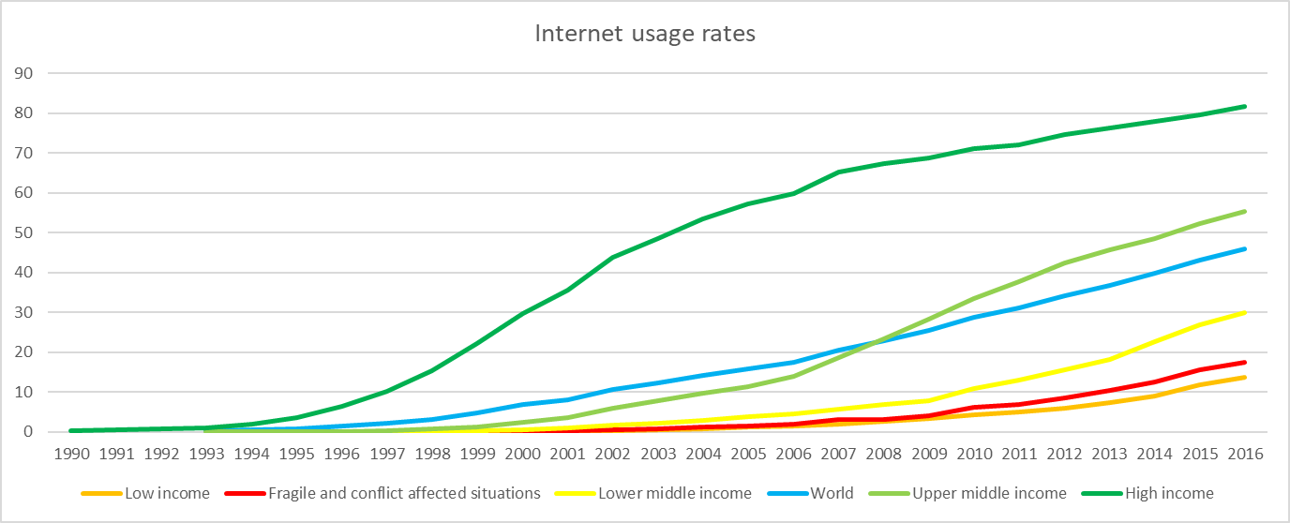

Figure 1 (Adapted from World Bank data)

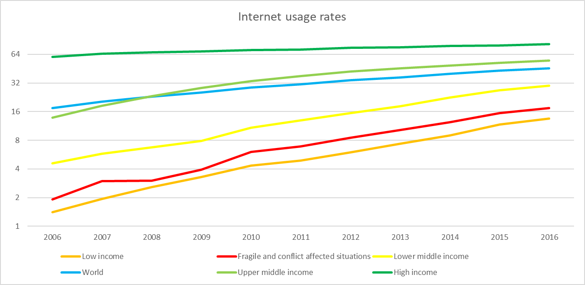

Figure 2 (Adapted from World Bank data)

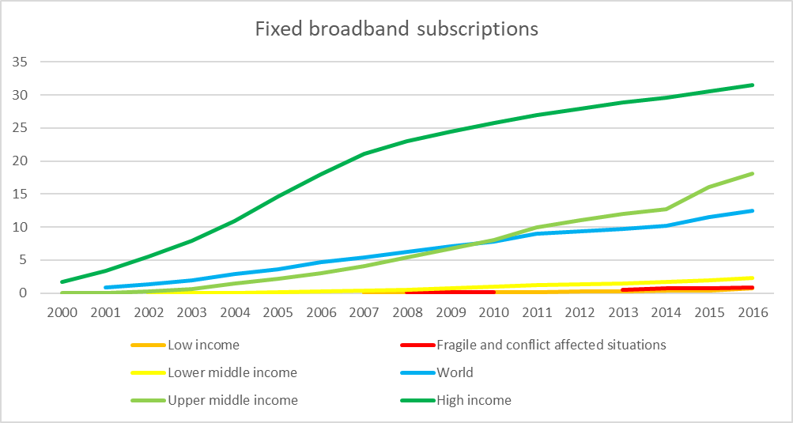

Figure 3 (Adapted from World Bank data)

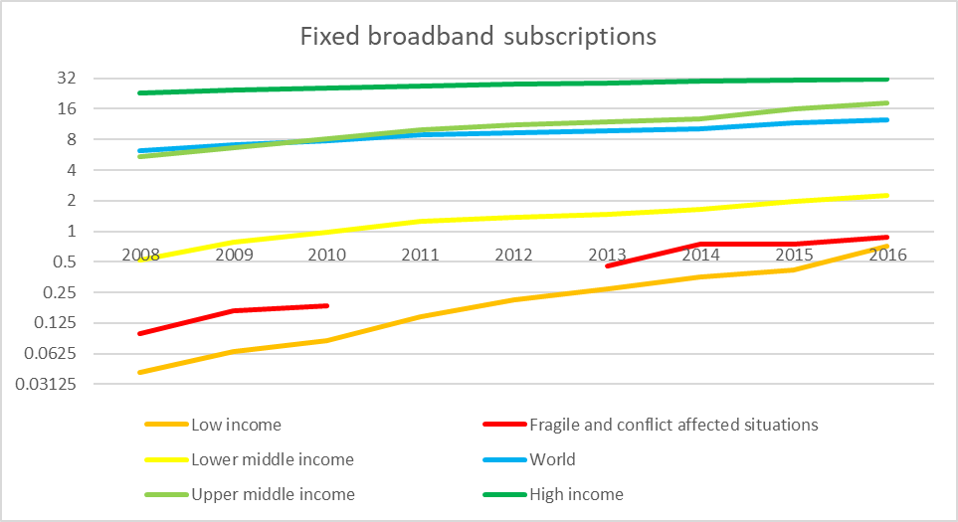

Figure 4 (Adapted from World Bank data)

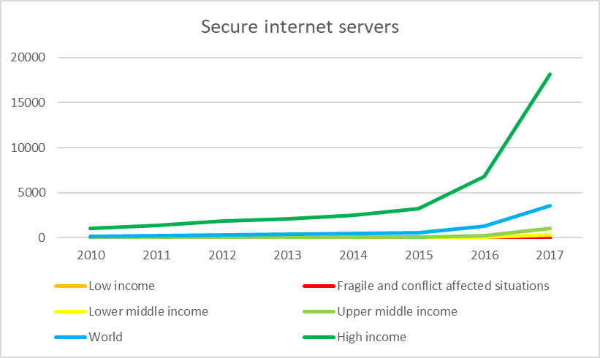

Figure 5 (Adapted from World Bank data)

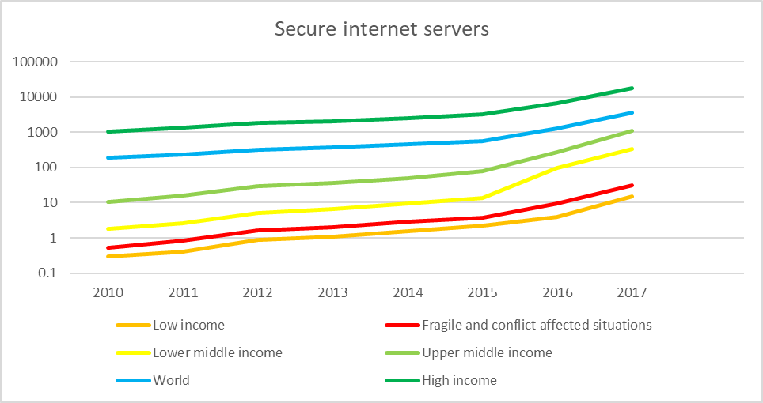

Figure 6 (Adapted from World Bank data)

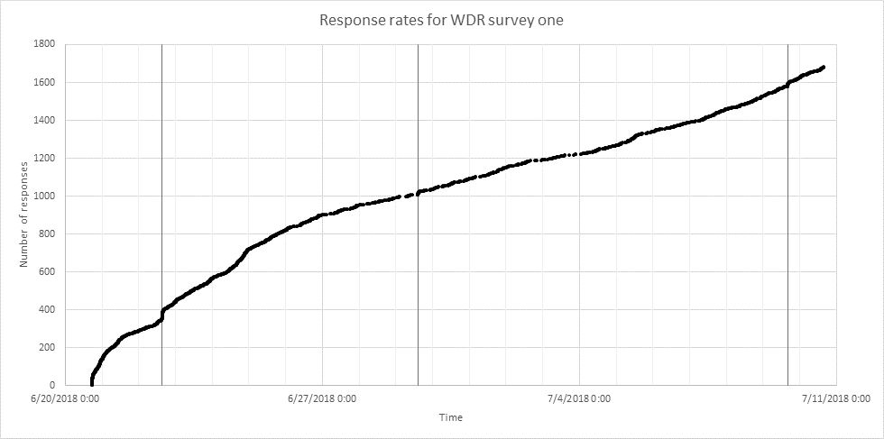

Figure 7

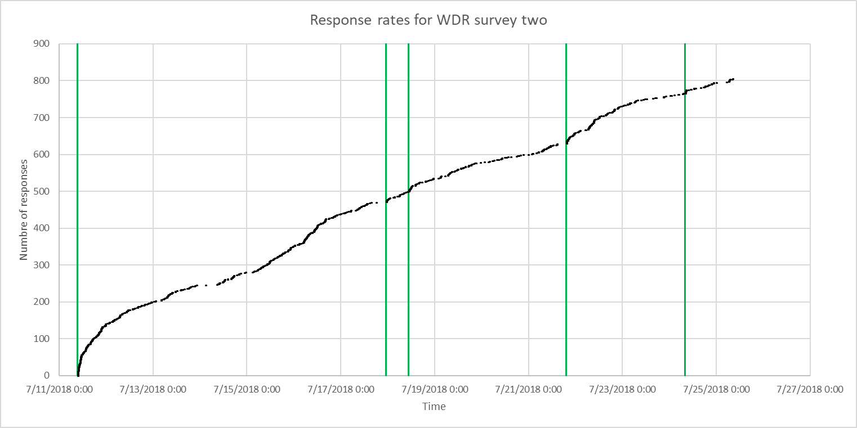

Figure 8



Figure 9

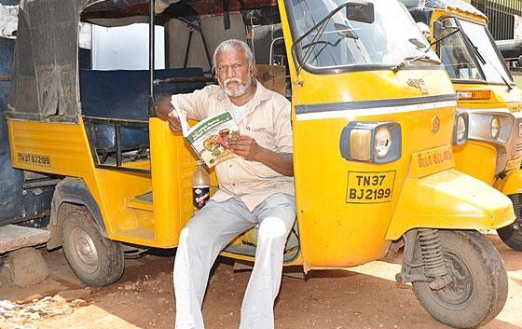

Figure 10



Figure 11



Figure 12



Figure 13

1. Katz and Krueger, “*The Rise and Nature of Alternative Work Arrangements in the United States, 1995-2015*”, Industrial Relations Section Working Paper 603 (2016).
2. Huws, et. al, “*Work in the European Gig Economy*”, Foundation for European Progressive Studies (2017).
3. Chen, Adrian. “*The Laborers Who Keep Dick Pics and Beheadings Out of Your Facebook Feed*”. Wired (October 23, 2014). https://www.wired.com/2014/10/content-moderation/
4. “*TCdata360”*. The World Bank. https://tcdata360.worldbank.org/indicators/fb6361a7
5. “*World Bank Country and Lending Groups”*. The World Bank. https://datahelpdesk.worldbank.org/knowledgebase/articles/906519-world-bank-country-and-lending-groups
6. “*Individuals using the Internet (% of population)*”. The World Bank. https://data.worldbank.org/indicator/IT.NET.USER.ZS
7. “*Fixed broadband subscriptions (per 100 people)*”. The World Bank. https://data.worldbank.org/indicator/IT.NET.BBND.P2
8. “*Secure Internet servers (per 1 million people)*”. The World Bank. https://data.worldbank.org/indicator/IT.NET.SECR.P6
9. Antoninis, Manos. “*A Global Framework to Measure Digital Literacy*”. UNESCO Institute of Statistics (2018). http://uis.unesco.org/en/blog/global-framework-measure-digital-literacy
10. “*2017 Digital Yearbook*”. Hootsuite (2018). https://www.slideshare.net/wearesocialsg/2017-digital-yearbook
11. Jaafari, Shirin. “*Internet cafes in Nigeria are quickly becoming a thing of the past*”. PRI (2015). https://www.pri.org/stories/2015-06-02/internet-cafes-nigeria-are-quickly-becoming-thing-past
12. Khanna, et. al. “*Evaluating and Improving the Usability of*

    *Mechanical Turk for Low-Income Workers in India*”. Microsoft (2010).
13. Gittins, Ross. “*India developing despite ignoring manufacturing sector*”. The Sydney Morning Herald (2014). https://www.smh.com.au/business/india-developing-despite-ignoring-manufacturing-sector-20141121-11r4xo.html
14. Ghani, et. al. “*Service with a smile: A new growth engine for poor countries*”. VOX (2011). https://voxeu.org/article/service-smile-new-growth-engine-poor-countries
15. Link to first survey: https://s3.amazonaws.com/mturk_bulk/hits/324992729/hF_7CaSLmNWN2EiCJxUAww.html
16. Link to second survey: https://s3.amazonaws.com/mturk_bulk/hits/327487264/evb_VLjfw0CUe6eixZoEaA.html
17. SSA example: https://s3.amazonaws.com/mturk_bulk/hits/325592139/iRVwLnKBgU4ap_mn4tfsqQ.html
18. LAC example: https://s3.amazonaws.com/mturk_bulk/hits/326450131/ALgPvrXvz85mLdf761YuJg.html
19. Sample task: https://s3.amazonaws.com/mturk_bulk/hits/327779643/cAPIriGD_OIeMRwxLePfZg.html
20. Questions: https://s3.amazonaws.com/mturk_bulk/hits/327265584/o15ta9rk4MsVpvb1nRsD1w.html
21. Howe, Jeff. “*The Rise of Crowdsourcing*”. Wired (2006). https://www.wired.com/2006/06/crowds/
22. Petres, Adele. “*Instead Of Traditional Aid, This Nonprofit Argues That We Should Give Work To The Developing World*”. Fast Company (2017). https://www.fastcompany.com/40462139/instead-of-just-giving-cash-this-nonprofit-argues-that-we-should-give-work
23. “*Why Work Matters*”. SamaSource. https://www.samasource.org/impact
24. “*eRezeki programme for low-income groups officially launched*”. Digital News Asia (2015). https://www.digitalnewsasia.com/digital-economy/erezeki-programme-for-low-income-groups-officially-launched
25. Hoong, Tan Kit. “*MDeC launches eRezeki programme to help the Bottom-40*”. The Star (2015). https://www.thestar.com.my/tech/tech-news/2015/06/17/erezeki-mdec/
26. Alias, Che Wan Badrul. “MDEC programmes bearing fruit”. New Straits Times (2018). https://www.nst.com.my/news/nation/2018/04/358286/mdec-programmes-bearing-fruit
27. Lim, Balqis. “MDEC's eRezeki and eUshawan initiatives are revolutionising the local cottage industry”. New Straits Times (2018). https://www.nst.com.my/lifestyle/bots/2018/03/349416/mdecs-erezeki-and-eushawan-initiatives-are-revolutionising-local